

ASSIGNMENT 1

INTERACTIVE APPLICATION - SYSTEM PROPOSAL AND DESIGN FOR COURSEWARE 9 -SQL 3

BY

HAZWAN IZZANI

ESAM ALAJAMI

HOTHAIFA ALHAMMADI

**Table of contents** 2

**1 Task 1 – Executive summary** 3

**2 Task 2 – Project goals** 4

**3 Task 3 – Characteristics of users** 5

**4 Task 4 – Content Specifications**

4.1 Text (Hothaifa) 6

4.2 Audio (Hothaifa) 6

4.3 Graphics (Esam) 7

4.4 Video

4.4.1 Video (Esam) 7

4.4.2 Video (Hazwan) 7

4.5 Animation (Hazwan) 8

**5 Task 5 – Functional Specifications** 9

**6 Task 6 – Storyboards**

6.1 Homepage (Hazwan) 10

6.2 SQL aliases (Hothaifa) 10

6.3 View Table (Hothaifa) 11

6.3 Queries (Esam) 12

6.5 Join (Esam) 15

6.6 Advantages (Esam) 16

6.7 Indexes (Hazwan) 17

**7 Task 7 – Project Timeline**  21

**8 References** 22

**1 – Executive Summary**

A traditional learning approach means that the teacher directs the classroom where the students have less interaction with their learning materials. The teacher will be the only one who provides knowledge unlike learning through interactive multimedia where the teacher will play a role as facilitator. One example of a traditional learning approach is PowerPoint where students have no choice to control the educational materials provided, there will be a lack of collaboration between students and low collective learning. Another example is chalk and modern ways where students will not be able to acquire problem-solving skills as they will only follow what their teachers provide.

Interactive multimedia is a mixture of multimedia elements that lead to interaction between multimedia and the user. It is always used in everyday lifestyles. The benefits of using interactive multimedia for problem-based learning are:

* It is time saving and consistent. Instead of reading tedious slides that consume time, users can learn it through multimedia elements that will reduce time and get a better understanding as they can learn it at home, even if they missed their class during teaching as they provide an interaction that causes users to think creatively.
* It can be applied in our daily lives. Through interactive multimedia, users will exercise their hand as they will critically consider solving the problems they encountered during the interaction. Thus, this will allow them to implement what they have learned in their daily life.
* Students, independently and jointly, assume a major duty for their own instruction and learning.

In general, students that form groups together while using interactive multimedia for problem-based learning will allow them to determine real-life problems which require real-life solutions. Groping students for problem-based learning also helps to improve students that don’t excel during solo work and grasp new material, talk about their ideas and challenge each other in a constructive manner.

**2 - Project Goals**

**Project Title**

Interactive application - System Proposal and Design for Courseware 9 -SQL 3

**Project Goals**

This project is planned to make an interactive multimedia application for a lecture alternative of Courseware 9 -SQL 3 PowerPoint presentation. This assignment consists of the project plan and the beginning phases of the development of the application. It contains the conceptualization of the idea and the contents from the presentation. We have presented the goal of creating the application and the target audience expected to use this app. The storyboard plan is shown in this assignment to direct our plan towards a clearer image of the goal. Included are the various multimedia elements designed to be implemented in the later stages of development in Assignment 2 which will be tested and implemented.

**3 - Characteristics of Users**

Nowadays, with high technology evolutions people has aimed to system program instead of paper and manually procedures to perform their work. So that leads creating so many programs (Animate cc) is one of them which helps the users to conveying significant definitions of the topics through various multimedia elements such as animation, video, text, graphic and audio. Nonetheless, it will not be a good way, if it is made in user-unfriendly and complicated way, instead using a user-friendly method. The users of the interactive multimedia enquire user-friendly interface of the project and would like to get an information of lecture in a simple way and can understand it directly. Users also want to learn not only in the classes and prefer to self-study from the internet. They also hope that can get some addition information such as video, audio, animation or graphic in the teaching materials.

Generally, intended users looking for much more than usable system, looking for easiness, efficiency, entertainment, excitability, speed and understanding properties at using program which are existing in multimedia system.

This multimedia system can attract users by putting some interesting thing such as button to line the additional information like video link which is make the users to access more information. Other than that, it can help users to imagine difficult concepts or procedures more easily by using static or dynamic multimedia **Using the audio, video or animation in the multimedia can let the lecture be more interesting and vivid. Compared with the traditional learning, users will not be wasting too much time** learning the presentation and insufficient for practice (Mirza, 2012). Moreover, using multimedia system can let users have better understanding on what they read and sufficient time for more practice. So, therefore multimedia element is so convincing for the user to used it

**4 – Content Specifications**

Multimedia elements consists of text, animation, graphic, video and audio and each has a specified function in providing an information to the user interactively and engrossing illustrations. The integration of these 5 elements can be done using authoring tools such as Adobe Animate CC, PowerPoint and extra which provides user interaction where it gives a clearer picture of the information that was provided to audience.

**4.1 Text** (Hothaifa)

Multimedia has been used in many different aspects in our lives, for example in the field of business, entertainment and the sciences. Content and functionality are created by those multimedia elements that were the primary characteristic of a multimedia system. Multimedia elements consists of text, audio, graphic, video and animation and each has a specified function in providing an information to the user interactively and engrossing illustrations. They can be used in word documents, spreadsheets or presentation aid to make an interesting illustration. The graphic, audio and animation can be built from scratch and can be imported from collections of clip media.

For the multimedia elements, I would use text. It is the basic element of multimedia. it involves the use of text types, sizes, colours and background colour. In multimedia application, the uses of text can be linked through by all the screen and media. When using text, users can clearly understand and know that what we want to convey and pass on. We also can use text to write a caption at the bottom of the graphic or picture as an additional explanation to let users more understanding.

**4.2 Audio** (Hothaifa)

The audio into a multimedia application will provide the user with information not possible through any other method of communication. Audio can also provide users more clearly understanding of information presented in multimedia. Users are easy add audio at any time because audio can get anywhere from their electronic devices such as laptops, tablets or smart phones. It also gives feeling and relaxation to the user effectively. By the way, in education it can be distracting so we did not use.

**4.3 Graphic** (Esam)

In recent years, the development of computer OS and the internet, Graphic, which is produced by drawing, carving or by computer graphic technology, has conveying a specific idea to the people, the users, by visualizing the meaning of the information. Basically, visual stimuli to humans are a great catalyst for stimulating the human brain. Moreover, there are many scholarly articles that suggest that if users concentrate on graphics, their memories will last longer and lead to learning sooner. When visual inputs are shown to the user, user gets attention about the topics shown through visual inputs. This progress lastly reaches to long-term memory, which we usually call as ‘learning’.

Our project’s aim is to convey the information of the topic friendly by using user-friendly interface and to give definite meanings. We are going to put various graphics related to the topics.

**4.4 Video**

**4.4.1** (Esam)

Video differs from animation where it is concentrates more on live recording where the process of capturing, recording, processing, transmitting and reconstructing a video in motion. Even though, video takes up most of any device’s storage, storing it is easy as it works similar to storing other files. (Banerji, 2010) Video combines audio and photo realistic image sequence where it makes it easy for the creator to deliver the intended message to the user. In addition, there is also 2 aspects of video which is similar to audio which are analog video and digital video. A continuous signal in a distinct period is known as the analog video whereas digital video is the one commonly used in multimedia where it produces photo realistic image sequences. We didn’t plan to include a video in our project.

**4.4.2** (Hazwan)

A well-executed, carefully planned video can create a vast difference in a multimedia application. Most of the times, video can convey message easier than text and image due to the presence of atmosphere as well as tone able to present to the viewer. However, in an education setting, videos can be distracting to the students with the reason of loud or flashing images. Refutably, they provide a further understanding in sciences but not in text heavy settings such as literature or computing, i.e. coding. It may be easier to read the text to understand. Therefore, the need of video is unoccupied.

**4.4 Animation** (Hazwan)

Using the appropriate software, we can visualize images into a moving form of 2-Dimensional and 3-D. The object desired to be in animation can be directed through various movements and activities which can be further detailed complex animations by a script. By choosing the right tool, animation sequences can be tweak. This can be brought by planning simple movements in 2-Dimensional or by adding textures and another dimension which allows depth. Animation can be sync with sound to create movies and even a way of interaction such as animated movies or games.

In our project, we will be using various animation techniques to create an enveloping attraction to the user (which are students) capable of understanding without sort of confusion with text themselves. As it will be used in education, we opt for clear 2-D animation to grab the attention and simultaneously be filled with information.

**5 – Functional Specifications**

This multimedia application has planned a few functional specifications designed to create an interactive platform for the user to use. According to the storyboards and drafts, the planned system will contain these:

1. Red and white background layout in all pages with the home page containing an animation at the beginning as you open the page. The animation will appear as a white fluid in the red container background filling to the half of the page. Various objects, buttons and text will alternate colours as they encounter the liquid. White text will become red and vice versa.
2. Buttons in the following pages after home screen will move to their designated place according to the coordinated page. 6 main pages represented as a circle indicates it. The circle button will fade as they are clicked with the background.
3. As they have subpages and contents, the placement of the subpage is at the right edge. Current page will be of red text and white background with the possible pages direct as white text and red background. They will move when switch pages.
4. Arrow buttons at the bottom will indicate if the page can go next or previous with black arrows while no pages after shown as grey. Hovering the button will be highlighted as red border and white fill.

**6 – Storyboards**

6.1 Homepage (Hazwan)

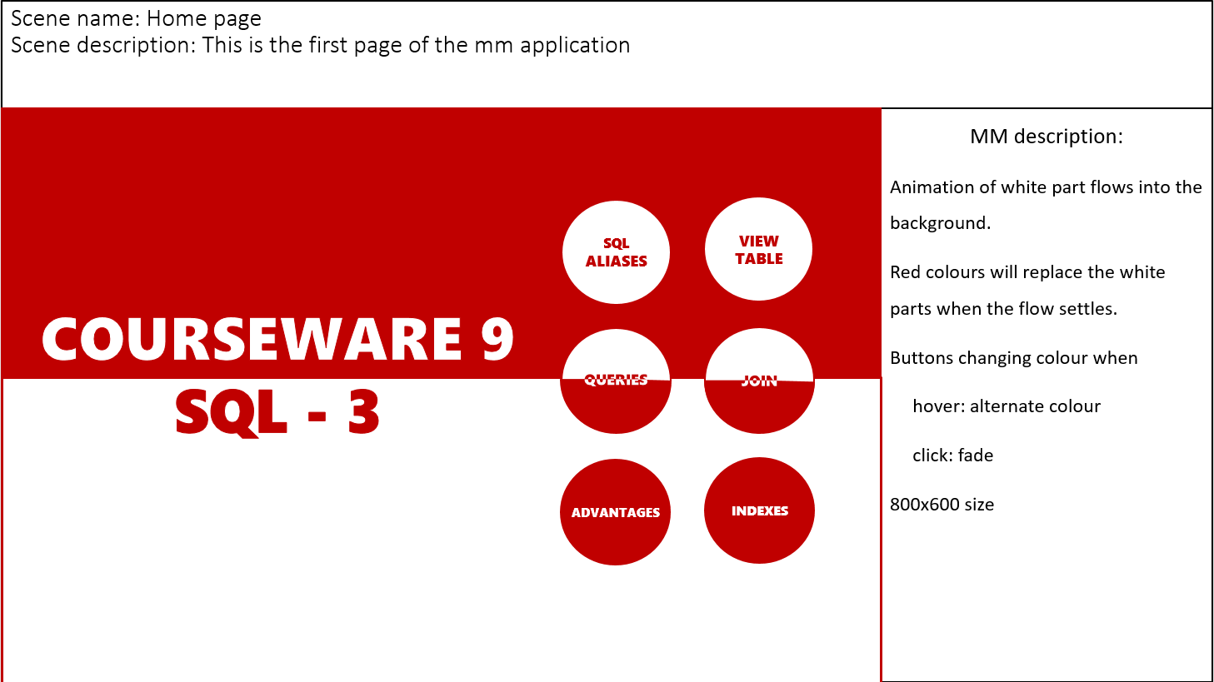

6.2 SQL Aliases (Hothaifa)

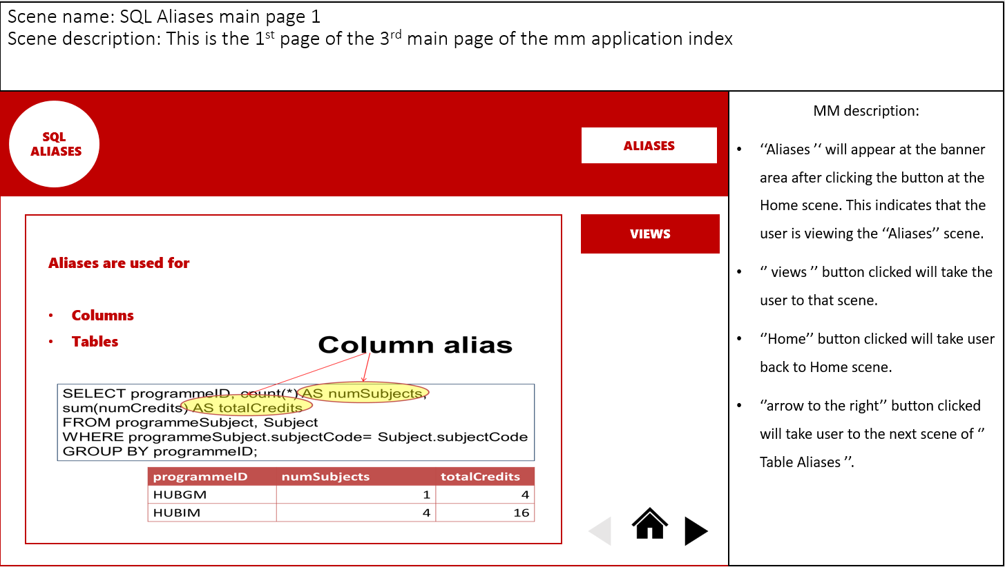

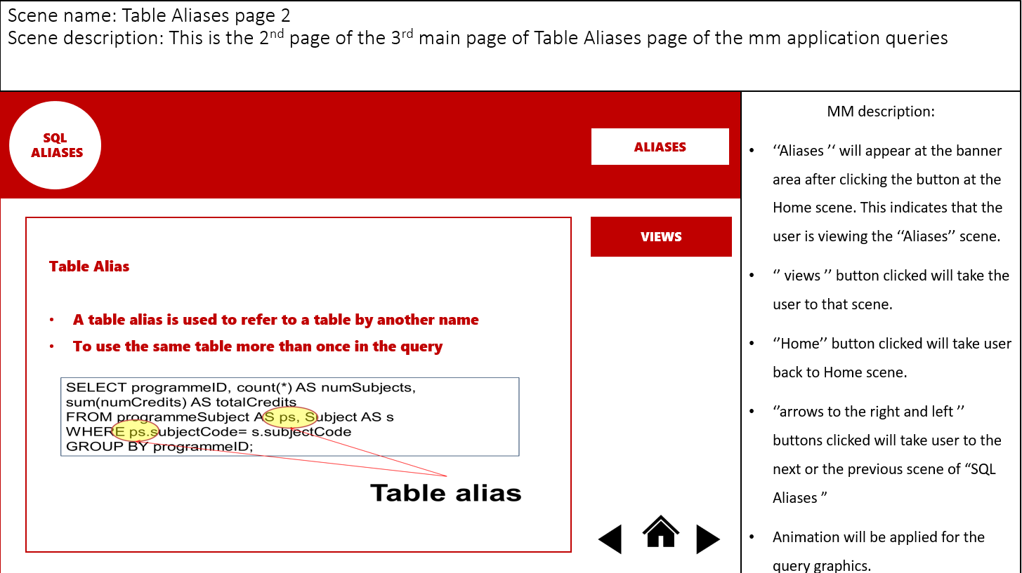

6.3 View Table (Hothaifa)

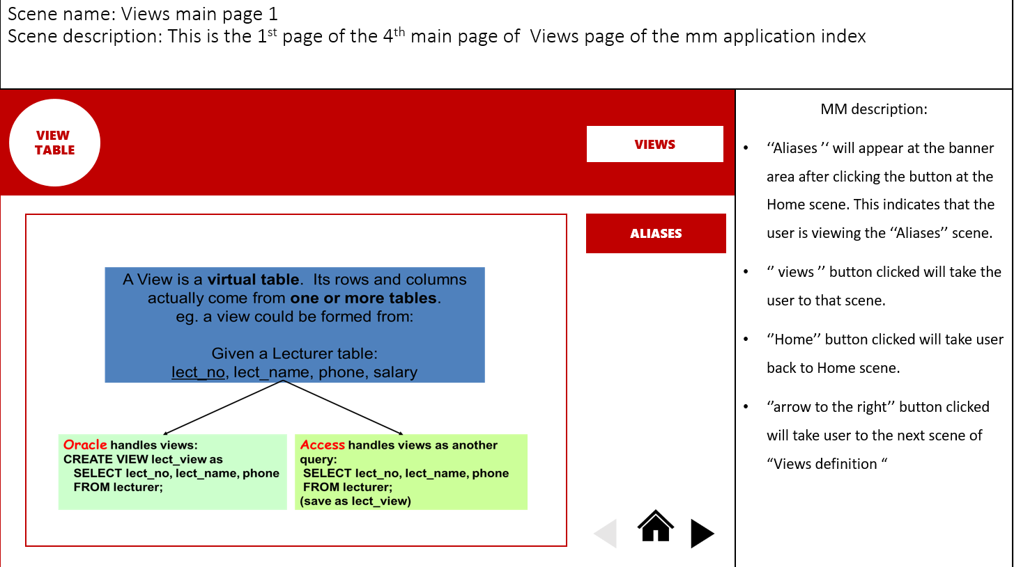

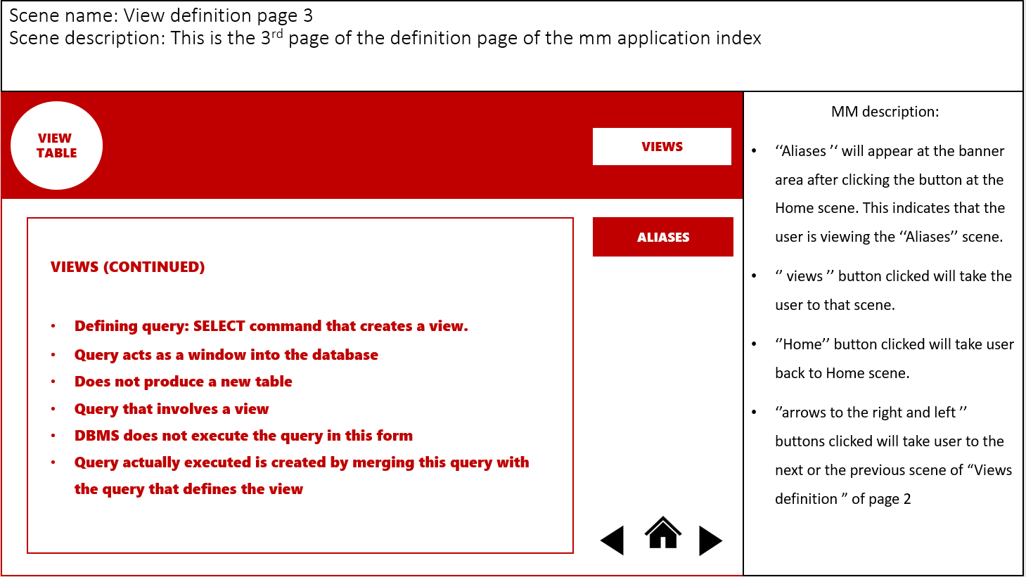

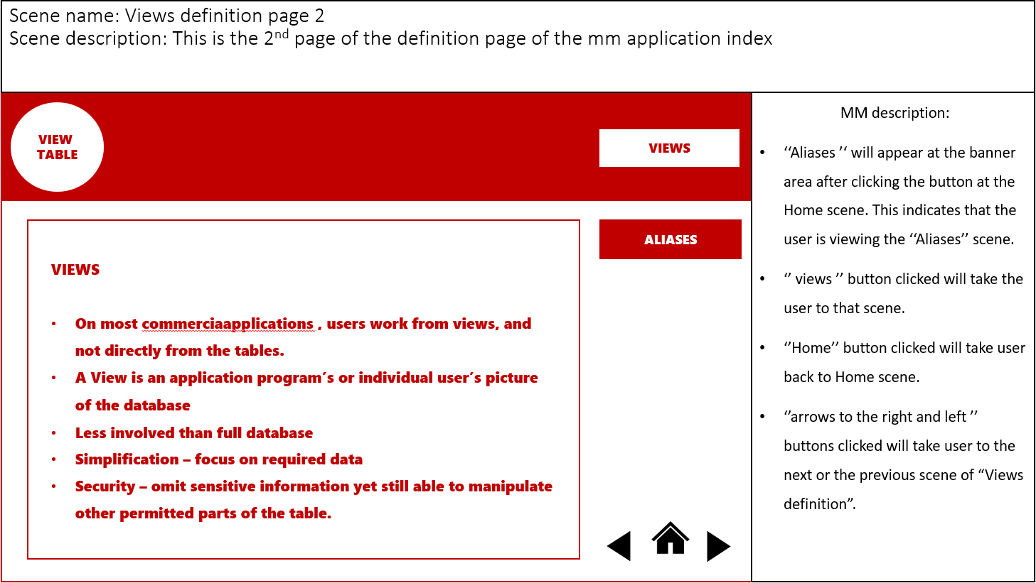

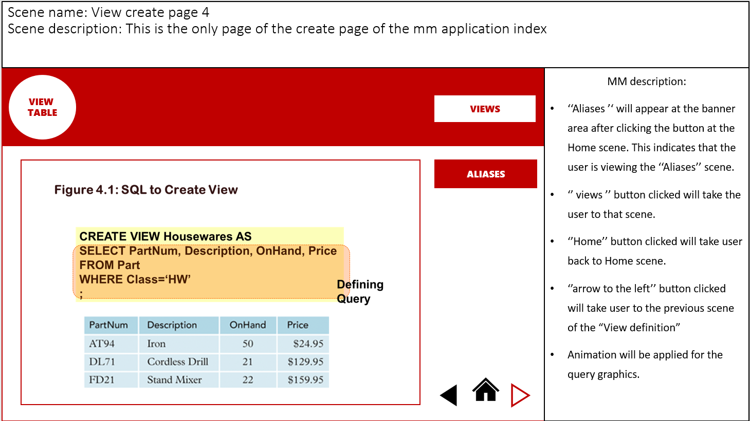

6.4 Queries (Esam)

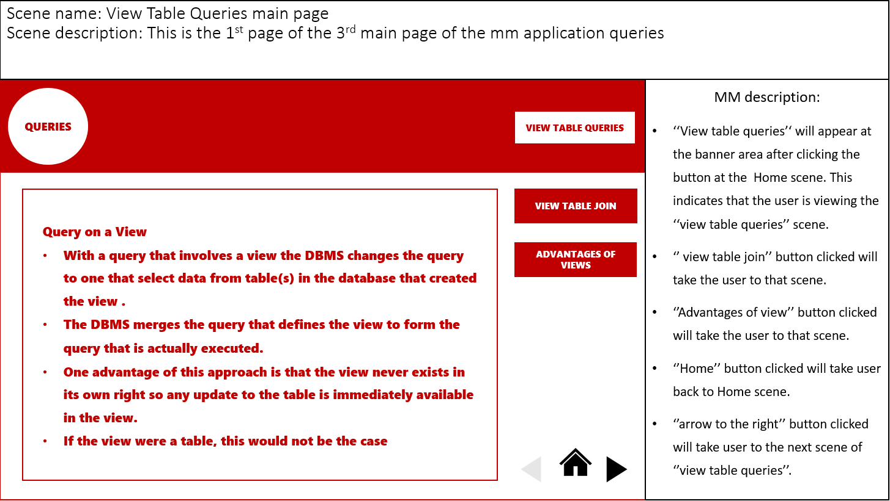

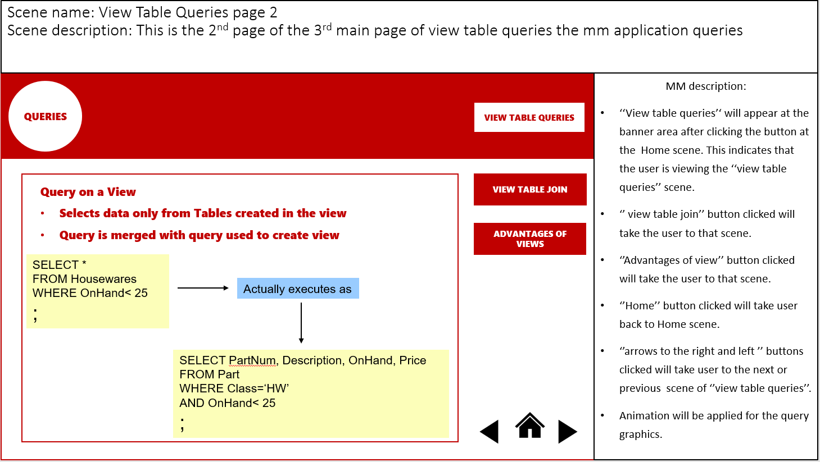

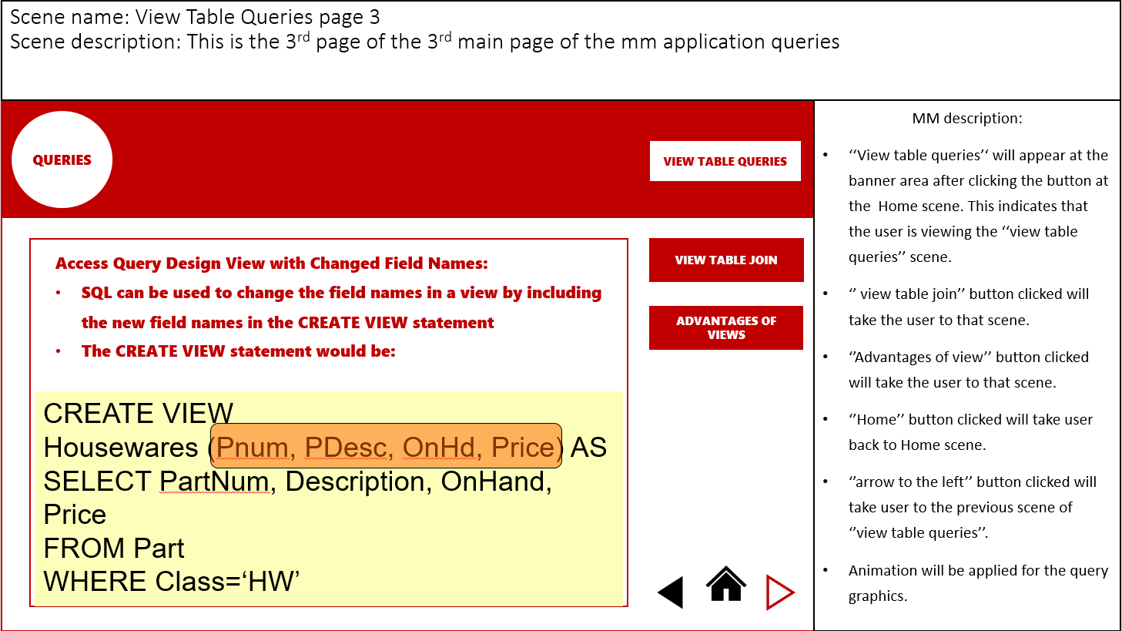

6.5 Join (Esam)

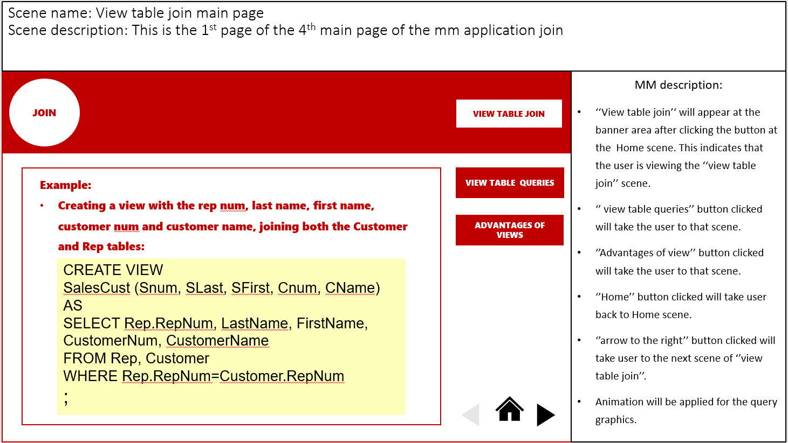

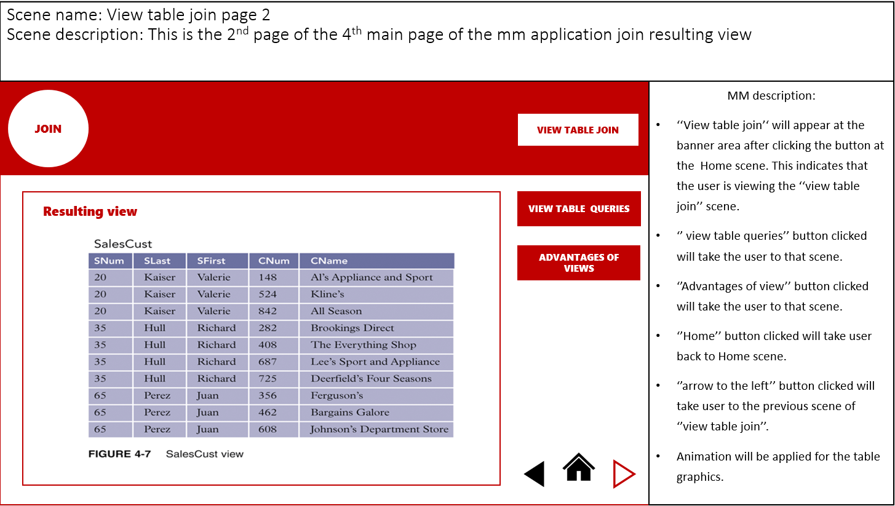

6.6 Advantage (Esam)

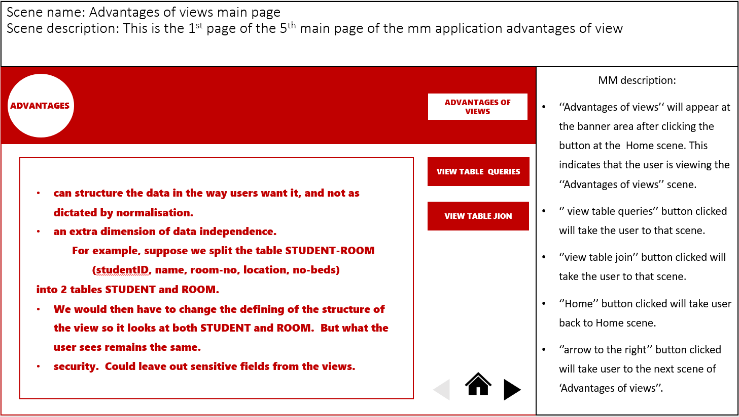

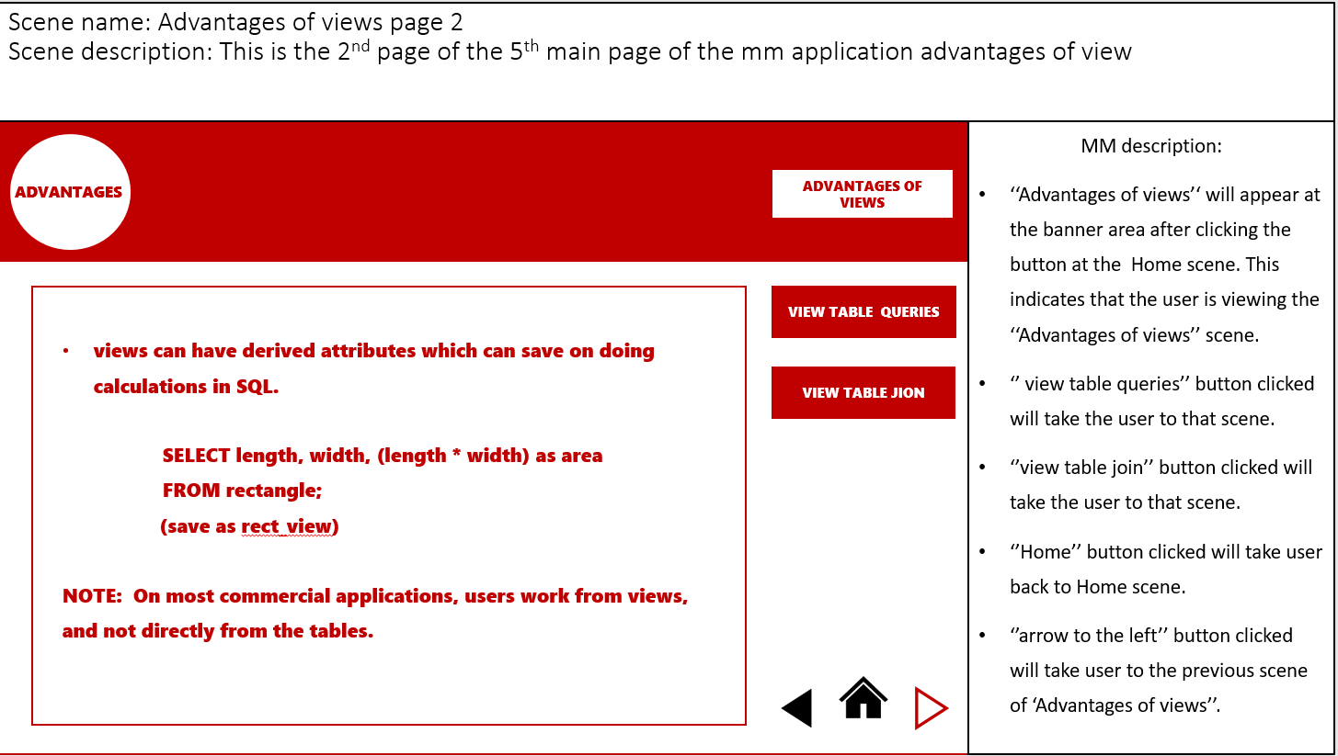

6.7 Indexes (Hazwan)

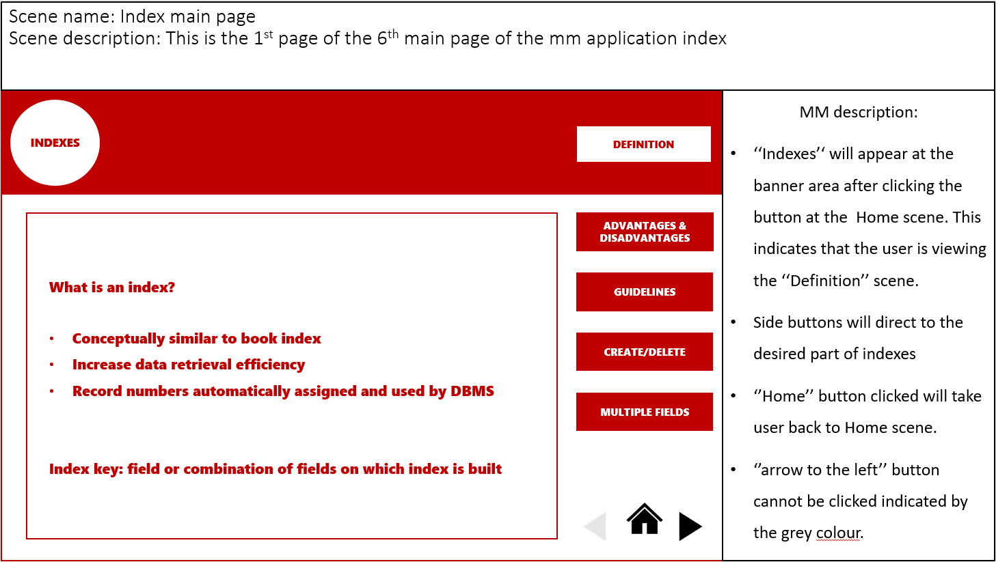

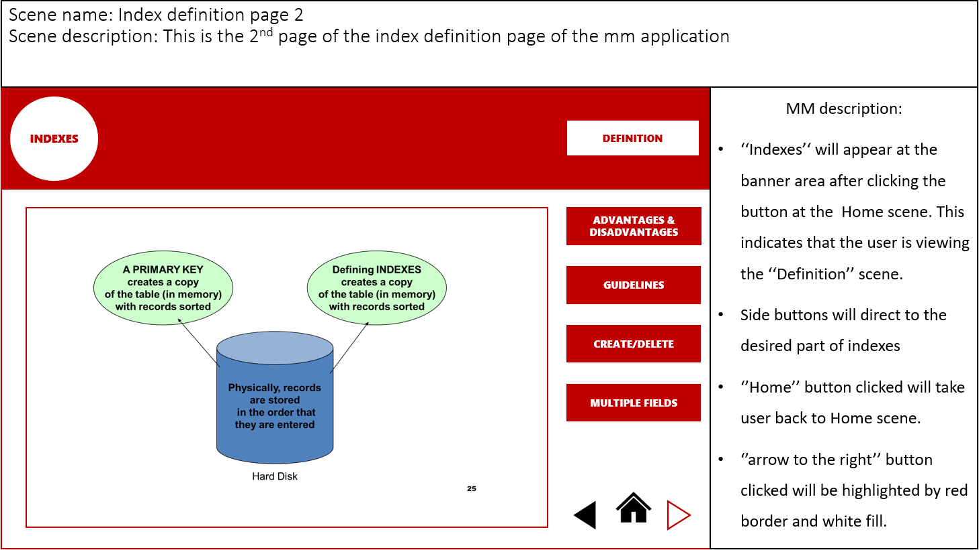

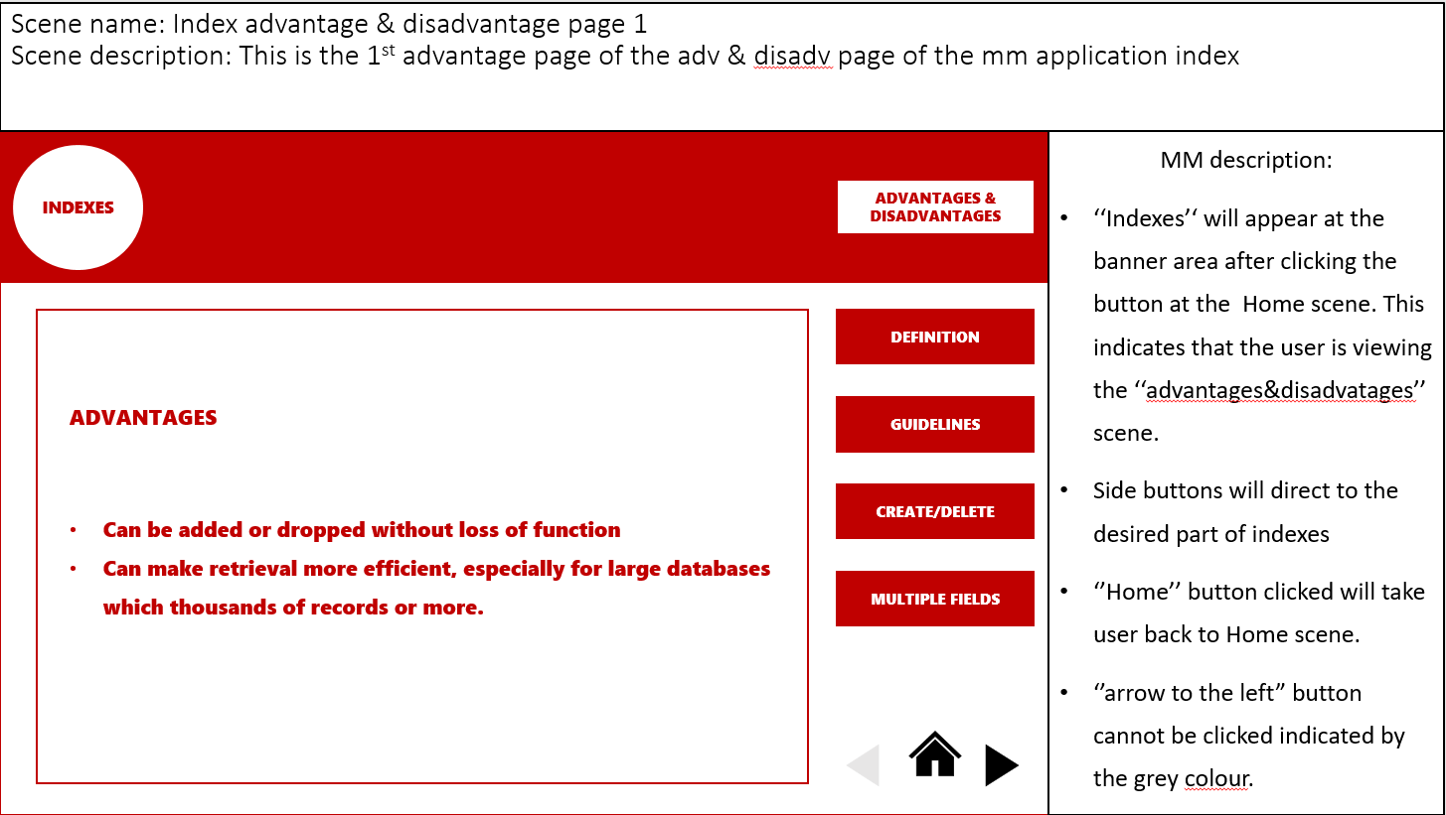

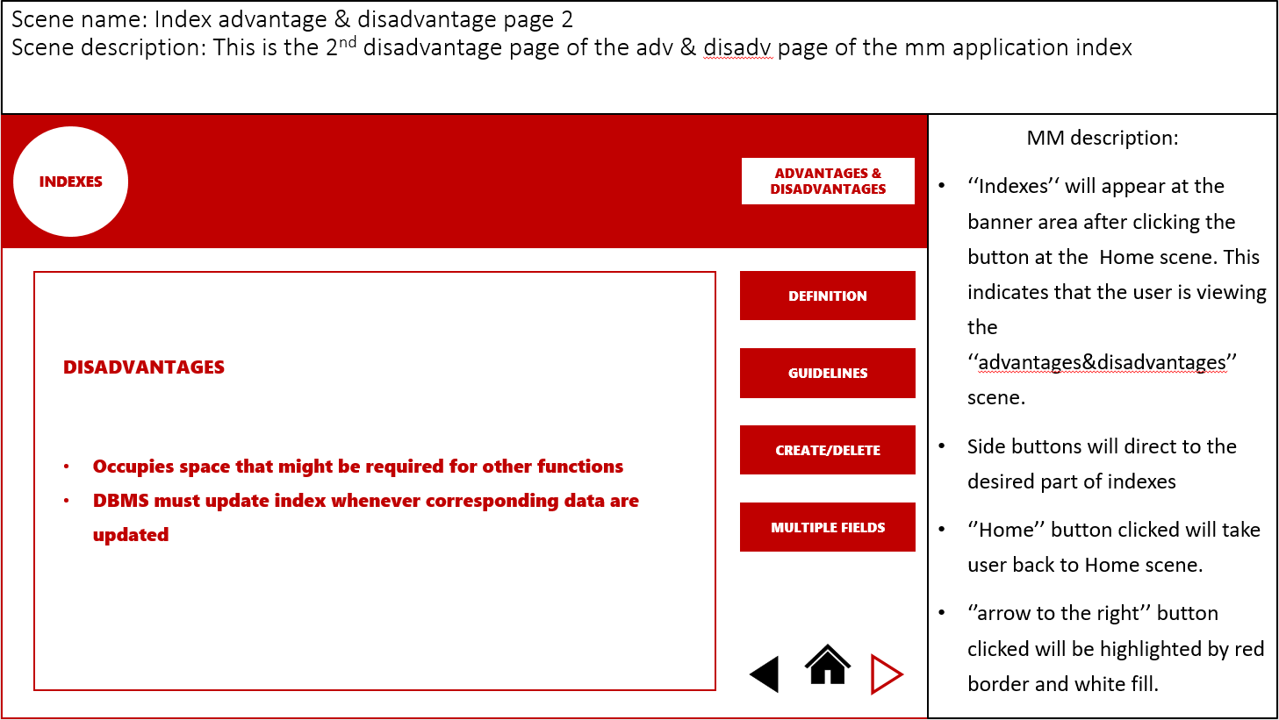

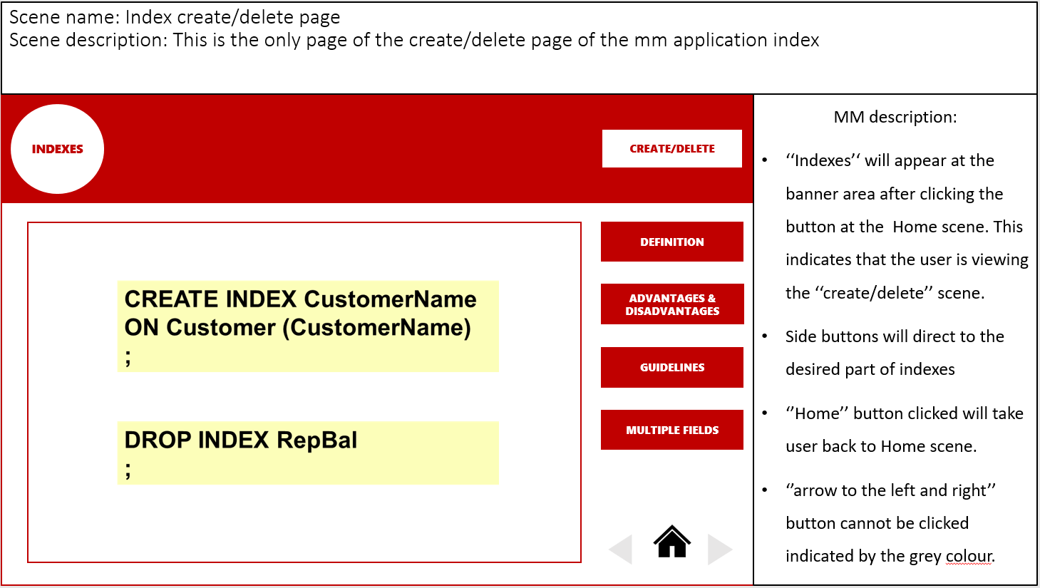

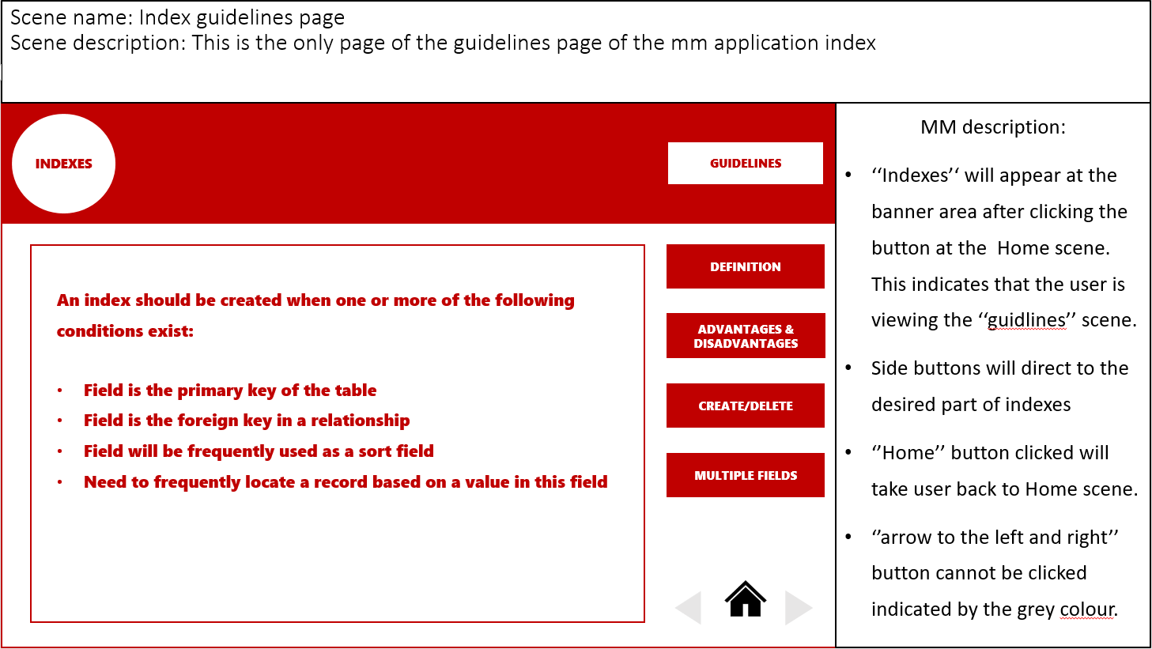

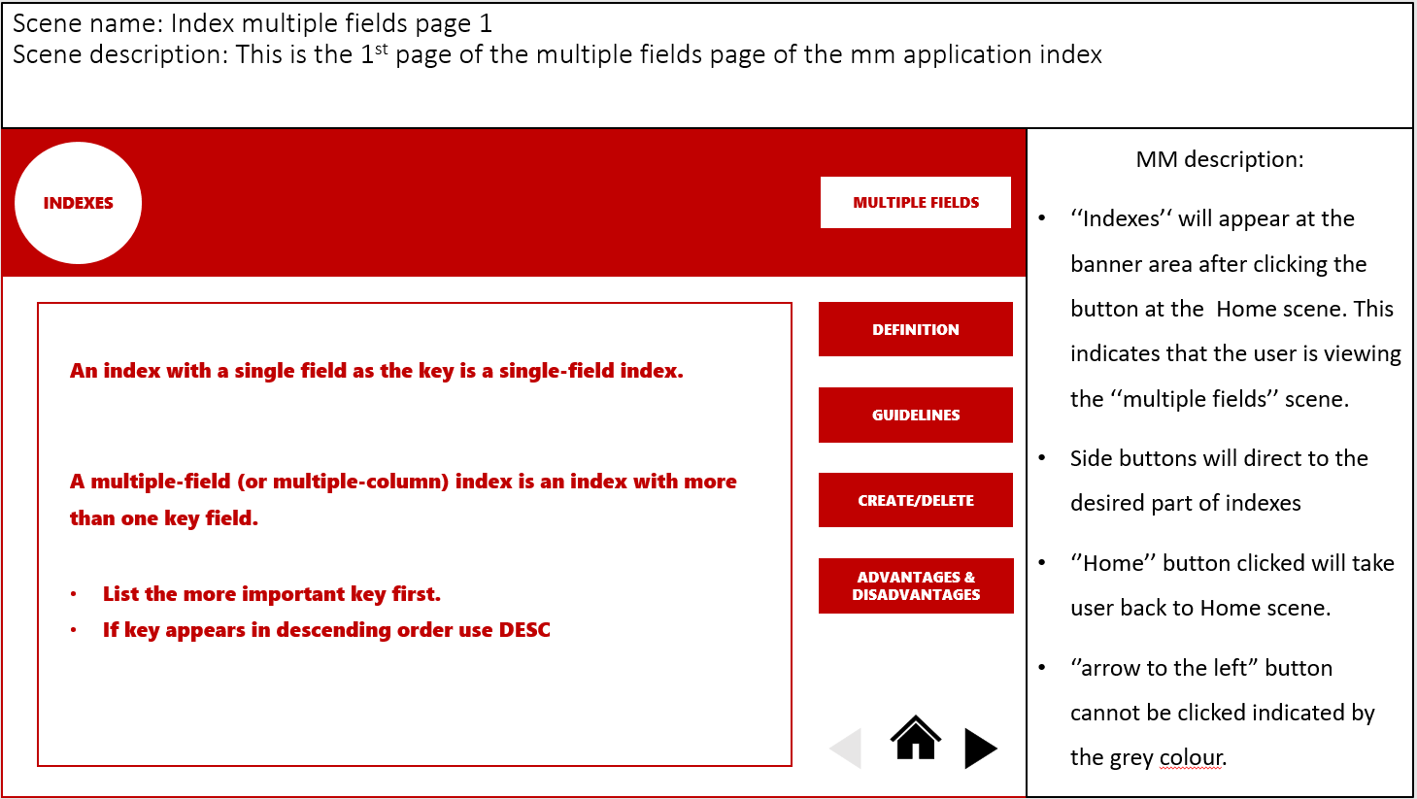

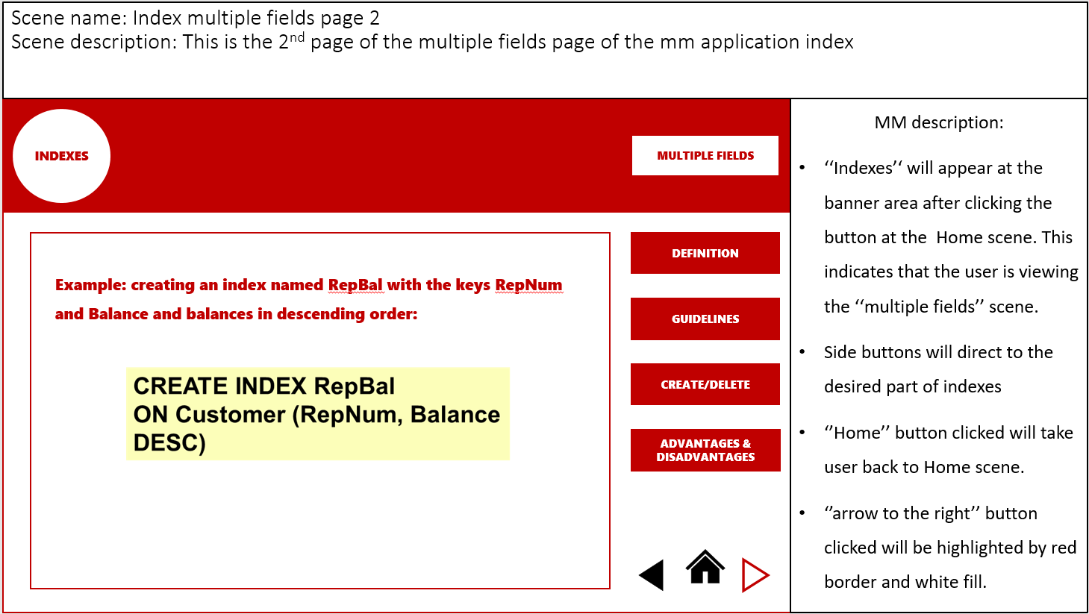

**7 - Project Timeline**

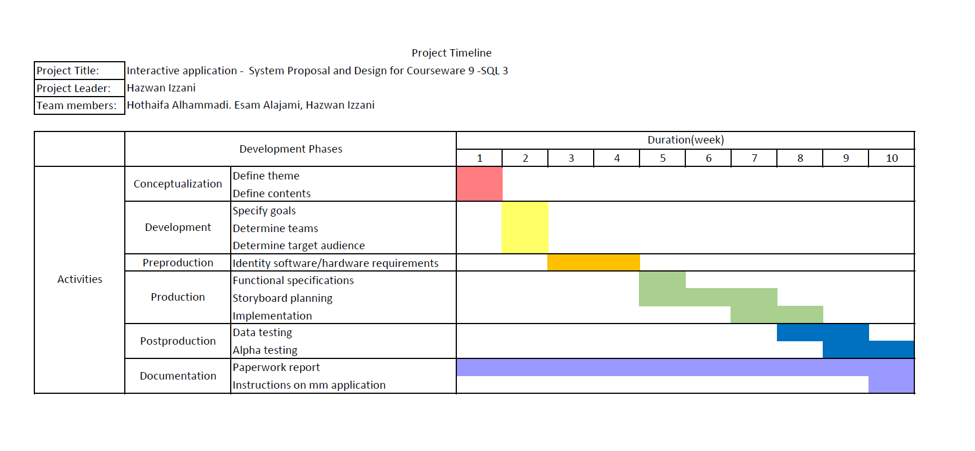

**8 - References**

Principles of multimedia

Parekh, R. (2006). *Principles of multimedia*. New Delhi: Tata McGraw-Hill.

<https://books.google.com.my/books?id=mM2DIfPvwrsC&pg=PA1&source=gbs_toc_r&cad=3#v=onepage&q&f=false>

#### Multimedia technologies

Banerji, A. and Ghosh, A. (2010). *Multimedia technologies*. New Delhi, India: Tata McGraw Hill.

<https://books.google.com.my/books?id=3PIHejE3tysC&pg=PA1&source=gbs_toc_r&cad=3#v=onepage&q&f=false>

Multimedia: Making It Work

Your Bibliography: Vaughan, T. (2011). *Multimedia*. 8th ed. McGraw Hill.

<https://www.slideshare.net/azmankadir/multimedia-element-presentation>

<http://202.114.32.200:8080/courseware/208405/20840511/context/Text/EC15_2.htm>

<https://www.quora.com/How-do-the-5-elements-of-multimedia-work>

<https://www.simplyeffectivewebdesign.com/five-elements-of-multimedia/>